Who’s Who in One Health

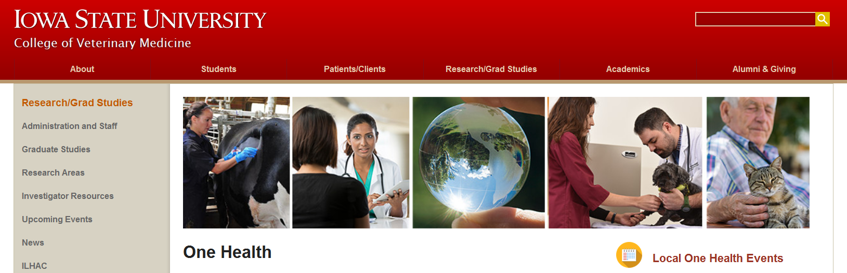

- Organization/ Group Name and website url: Iowa State University College of Veterinary Medicine One Health Initiative
https://vetmed.iastate.edu/research-grad-studies/centers-institutes-and-initiatives/one-health

- Description and Scope of One Health Activities education; research collaboration; and outreach aligned with the mission of One Health

- Key Collaborators and Participants Iowa State University; University of Iowa; USDA National Centers for Animal Health, Ames, IA; Center for Food Security and Public Health (CFSPH); AVMA; AAVMC; NIH; CDC; One Health Commission

- Type of Organization
Academic Institution

- Address of Organization/ Group
College of Veterinary Medicine
Iowa State University
1800 Christensen Drive
Ames IA 50011-1134

- Contact(s) (with check box to agree to share)
Email candreas@iastate.edu
Telephone 515-294-0869
Agree to share contact information on the One Health website - yes

- Sources of funding for Organization/Group
Federal grants; private

- One Health Course/Certificate/Training / Program Offered by Organization or Group

Title of Course/Certificate/Training: Zoonoses- Protecting People and Their Pets
Contact person’s name and email: zoonoses@iastate.edu.
Link to informational web page: http://www.cfsph.iastate.edu/Zoonoses-Course/

Title of Course/Certificate/Training: Emerging and Exotic Diseases of Animals
Contact person’s name and email: fadcourse@iastate.edu.
Link to informational web page: http://www.cfsph.iastate.edu/EEDA-Course/

Title of Course/Certificate/Training: Secure Food Supply
Contact person’s name and email: http://www.cfsph.iastate.edu/About/contact.php
Link to informational web page: http://www.cfsph.iastate.edu/Secure-Food-Supply/index.php

Title of Course/Certificate/Training: Veterinary Immunology and Principles of Vaccination (17 hours)
Contact person’s name and email: vetimmune@iastate.edu
Link to informational web page: www.cfsph.iastate.edu/Immunology/full-course.php

Title of Course/Certificate/Training: Introduction to Veterinary Immunology (4.5 hours)
Contact person’s name and email: shortcourse@iastate.edu
Link to informational web page: http://www.cfsph.iastate.edu/Immunology/short-course.php

Title of Course/Certificate/Training: Introduction to the Principles of Veterinary Vaccination (3 hours)
Contact person’s name and email: immunehelp@Iastate.edu
Link to informational web page: www.cfsph.iastate.edu/Veterinary-Vaccinology-Course/index.php

Title of Course/Certificate/Training: Introduction to Animal Emergency Management
Contact person’s name and email: agencies and organizations may contact Dr. Kevin Dennison, Kevin.M.Dennison@aphis.usda.gov, (Western Region), or Dr. Jeanie Lin, Jeanie.Lin@aphis.usda.gov (Eastern Region)
Link to informational web page: http://www.cfsph.iastate.edu/Education-Training/introduction-to-animal-emergency-management.php

Title of Course/Certificate/Training: National Animal Health Emergency Response Corps (NAHERC)
Contact person’s name and email: http://www.cfsph.iastate.edu/About/contact.php
Link to informational web page: http://naherc.cfsph.iastate.edu/

Title of Course/Certificate/Training: Biologics Training Program
Contact person’s name and email: http://www.cfsph.iastate.edu/About/contact.php
Link to informational web page: http://www.cfsph.iastate.edu/IICAB/meetings/may2017.php

University enrollment required:

Title of Course/Certificate/Training: Masters of Public Health
Contact person’s name and email: Dr. Danelle Bickett-Weddle dbweddle@iastate.edu
Link to informational web page: http://www.cfsph.iastate.edu/MPH/

Title of Course/Certificate/Training: Biomedical Sciences Non-thesis MS (health professions)
Contact person’s name and email: Ms. Emma Hashman bmsgrad@iastate.edu
Link to informational web page: https://vetmed.iastate.edu/bms/Academics/One-Year-Masters

Title of Course/Certificate/Training: Graduate Certificate in Veterinary Preventive Medicine (entirely by distance education) -15 credits
Contact person’s name and email: Ms. Erica Hellmich ericah@iastate.edu
Link to informational web page: https://vetmed.iastate.edu/vdpam/academics/graduate-programs

- Other One Health Activities/Initiatives
(Symposiums, Summits, Workshops, Discussion Series, etc)
Title/description of program: Updated on webpage
Contact person’s name and email: Dr. Claire Andreasen candreas@iastate.edu
Link to program informational web page: https://vetmed.iastate.edu/research-grad-studies/centers-institutes-and-initiatives/one-health

Title/description of program: Annual One Health Lecture (Dr. Roger Mahr lecture series)
Contact person’s name and email: Dr. Claire Andreasen candreas@iastate.edu
Link to program informational web page: https://vetmed.iastate.edu/research-grad-studies/centers-institutes-and-initiatives/one-health

Title/description of program: Educational Products
Contact person’s name and email: http://www.cfsph.iastate.edu/About/contact.php
Link to program informational web page: http://www.cfsph.iastate.edu/Products/

- Brief History of Your Organization’s One Health Involvement

The Iowa State University College of Veterinary Medicine has a long history of engagement in One Health. The Iowa State College of Veterinary Medicine supports One Health in all our university land-grant missions of education, research, professional practice, and outreach. Our curriculum is presented by knowledgeable instructors in comparative animal and human medicine, and many specialties. These efforts are in collaboration with many university, college, and industry partners. We have long standing collaborations to improve animal and human health with the Iowa Regents Universities, especially the University of Iowa Carver College of Medicine and College of Public Health, and the USDA National Centers for Animal Health in Ames, IA. The College supports research related to animal and human health, especially in the areas of disease prevention, and maintenance of secure and safe animal food products. An annual One Health lecture series was established in honor of Dr. Roger Mahr in 2011.

- Additional Information
Additional Related Centers
Iowa Center for Advanced Neurotoxicology (ICAN) https://vetmed.iastate.edu/research-grad-studies/centers-institutes/ican

